**Overview**

The number of artifacts from the Long March period is quite large, and it is difficult to determine an exact figure, as many artifacts are scattered across museums, memorials, and private collections. The Long March is an important event in the history of the Chinese Communist Party, and the artifacts involved include documents, photographs, equipment, and sites. China's Long March memorials are generally distributed across Sichuan Province, Hunan Provinc, Guizhou Province, Gansu Province and Yunnan Province.

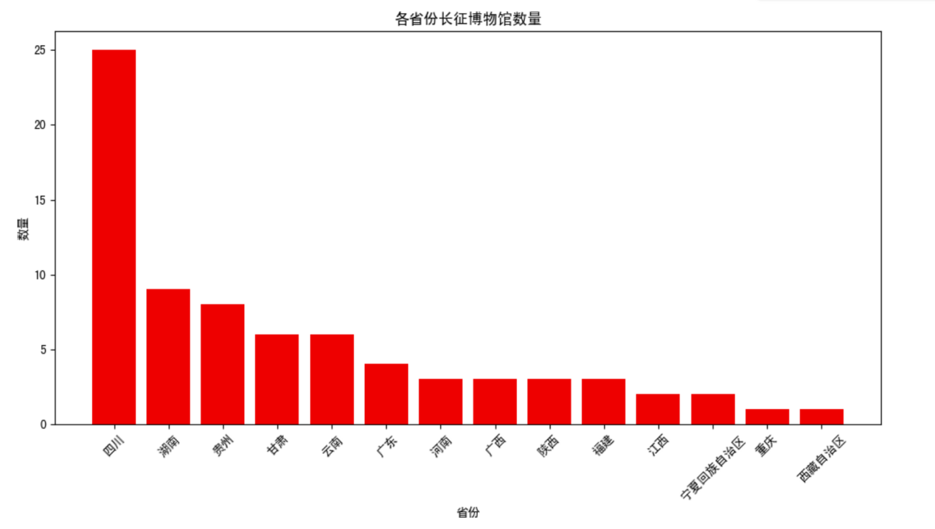

Quote: www.hongsehui.cn

For example, regarding the Long March artifacts in Shaanxi Province, as of 2016, there are a total of 142 sites related to the Long March, mainly distributed along the marching routes of the Central Red Army and the Red Twenty-Fifth Army. This includes 3 nationally protected cultural heritage sites, 10 provincial heritage sites, 42 municipal and county-level heritage sites, and 87 general immovable cultural relics (the protection level of which has not yet been determined).

Quote: 吕亚歌(2016).西省长征文物保护与利用研

**Long March Museum and Site Display**

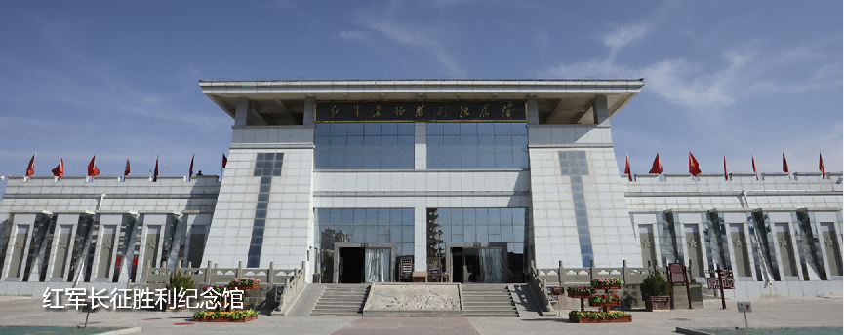

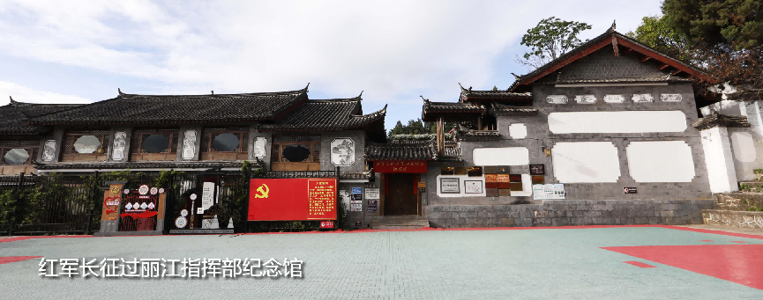

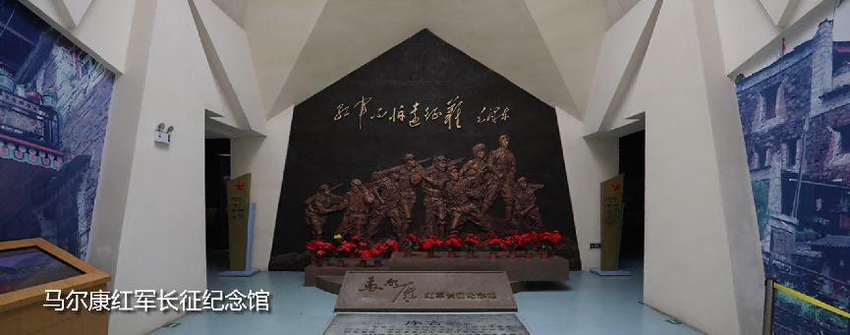

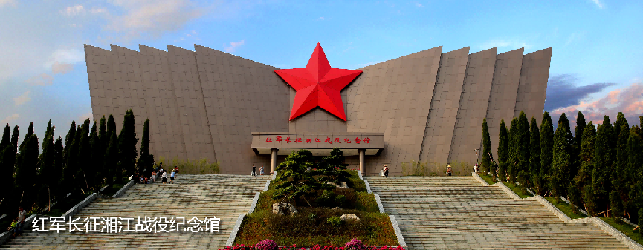

**Introduction and display of artifacts**

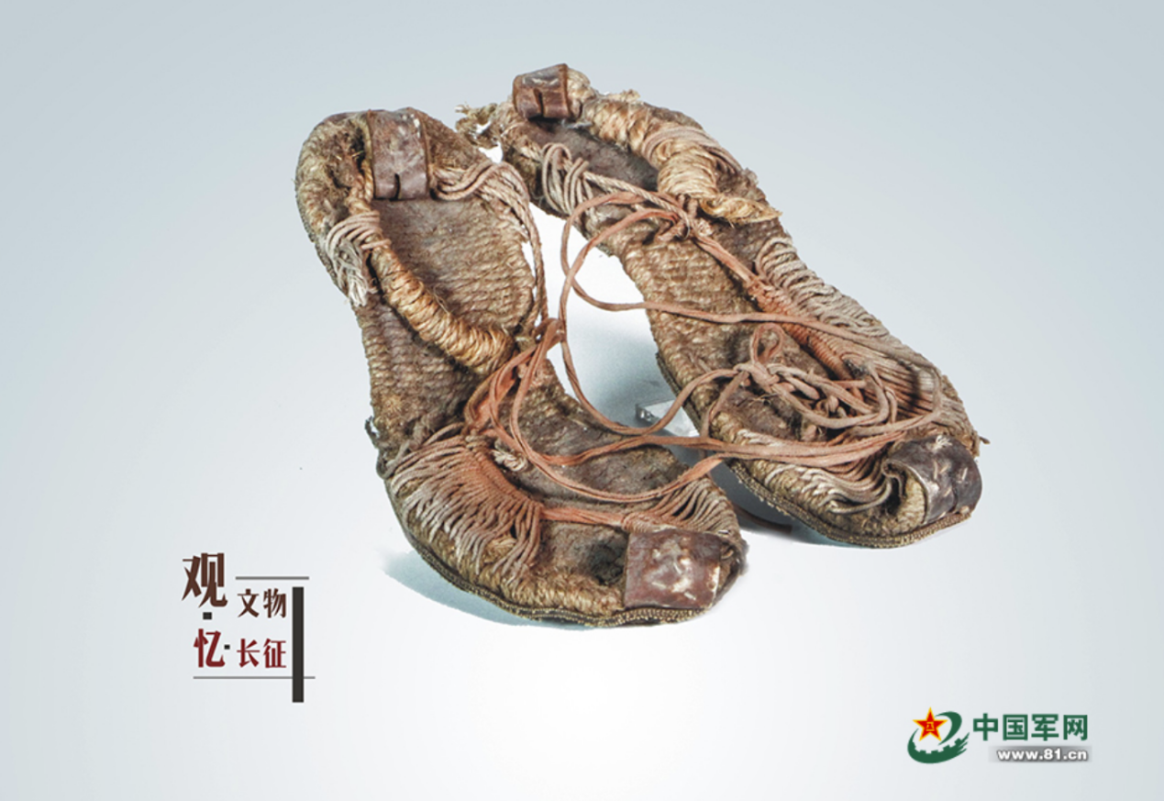

**Artifact: Hemp Grass Shoes**

**Specifications:** Approximately 27.5 cm long, 11.2 cm wide, and 1.5 cm high; currently in good condition.

**Material:** Hemp rope.

This pair of grass shoes is made primarily from hemp rope, crafted using traditional methods, and is referred to as hemp grass shoes. What makes this pair special is that it is not made from hemp rope alone but from several materials. The main part of the sole is made from braided hemp rope, while the toe and heel are reinforced with leather. The straps above the foot are made from cord, and notably, the bottom of the shoes is stitched with old tires, significantly enhancing their durability and comfort. This pair of grass shoes exemplifies how Red Army soldiers, in times of resource scarcity, utilized their ingenuity and made the most of available materials to solve their equipment challenges.

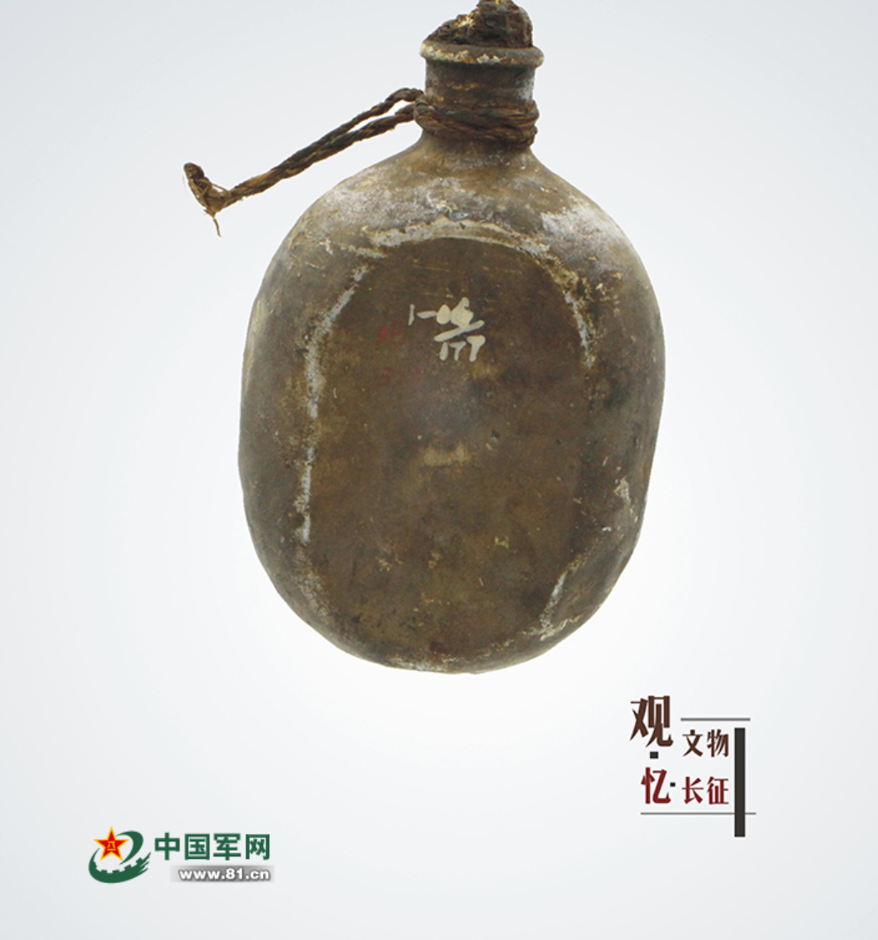

**Artifact: Water Bottle**

**D**ate****: 1935

**Description**:This water bottle is a trophy obtained by Comrade Guo Dajin before crossing the marshland.

The water bottle shown in the image was seized as a trophy during combat with the enemy while crossing the marshland in Sichuan after the Red Army crushed the enemy's fifth encirclement in 1935.The military water bottle is a standard container for soldiers to carry drinking water, classified as individual equipment, and is of significant importance for maintaining the combat effectiveness of the army. In modern China, military water bottles date back to the Qing Dynasty, when the Qing army was equipped with military water bottles produced by the Yongzeng Military Uniform Bureau in Beijing. During the Republic of China period, the Nationalist army used water bottles made from iron and zinc plates. During the Long March, most of the Red Army's military water bottles were captured from the Nationalist army.

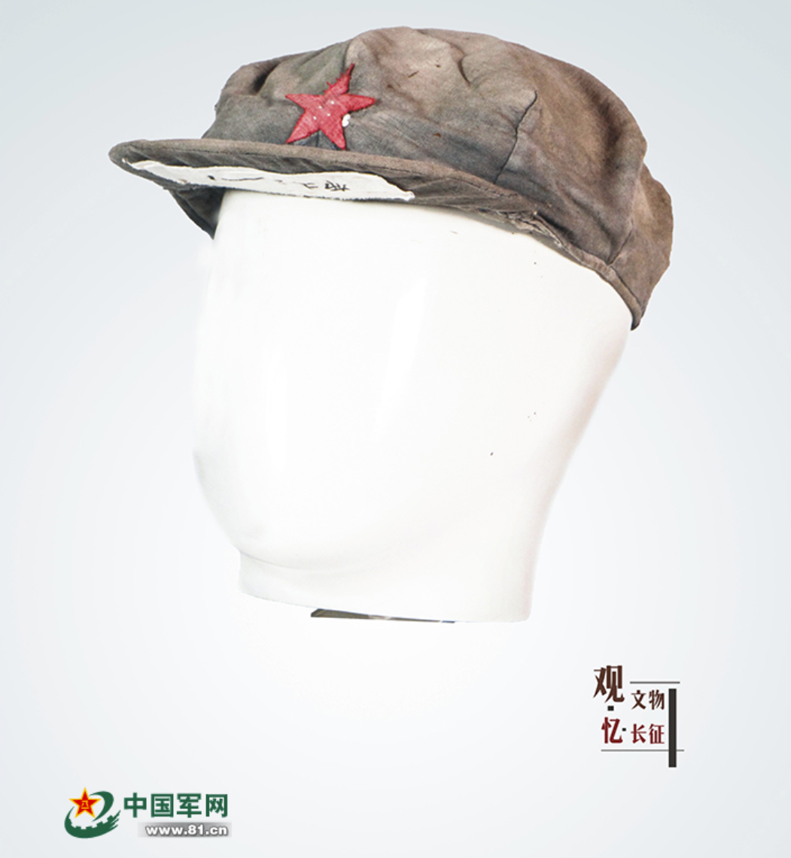

**Artifact: Military Cap**

**Specifications:** Diameter of approximately 20 cm, brim length of about 20 cm, width of about 6 cm, and a height of approximately 8 cm.

This military cap is one of the typical caps of the Red Army, gray in color, octagonal in shape, with a five-pointed red star prominently displayed at the center and a front brim. The cap has a diameter of approximately 20 cm, a brim length of about 20 cm, a width of about 6 cm, and a height of approximately 8 cm. This cap was worn by Liu Yongzhen, a soldier of the Red Sixth Army Corps, throughout the Long March, accompanying him through numerous hardships. After the successful completion of the Long March, he kept this cap as a cherished memento. In 1955, when the Lüshun Military Museum was established, Liu Yongzhen donated this beloved cap. In 1977, following directives from the General Political Department, the Lüshun Military Museum was closed, and all its artifacts were transferred to the Military Museum for preservation.

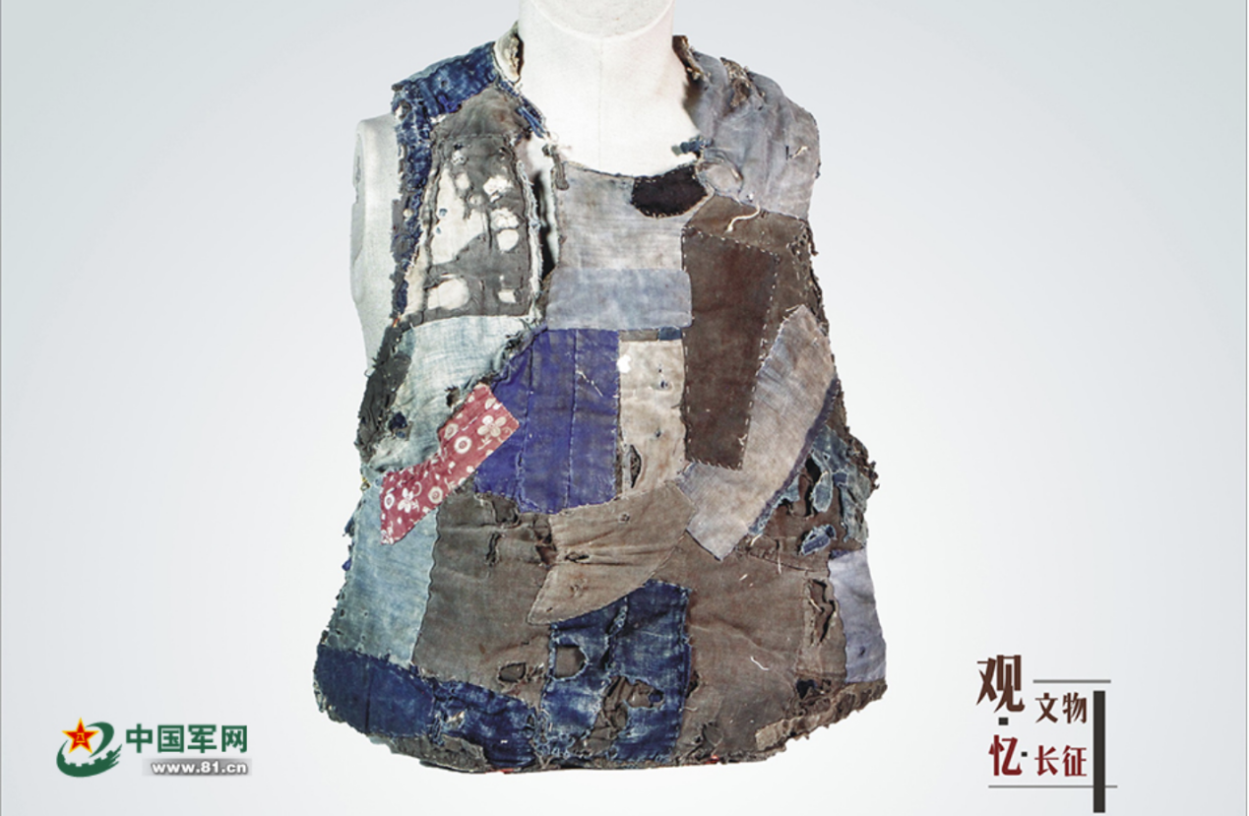

**Artifact: Cold-Weather Jacket**

**Specifications:** Approximately 58 cm long and 60 cm wide.

**Material:** Fabric and cotton, stitched together with thread.

This is a cold-weather jacket made of layers of patches. The material consists of fabric and cotton, stitched together with thread, and it has multiple areas of damage. It measures approximately 58 cm long and 60 cm wide.The marshland that the Red Army crossed is a highland wetland, often referred to as the "Land of Death" due to its muddy swamps. Even experienced herdsmen in the area hesitate to venture there during the rainy season. During this time, the marsh is filled with water and deep mud, and the weather is harsh, often marked by strong winds, heavy rains, and hail.As the Red Army crossed this marshland, their preparations were generally inadequate, with most comrades wearing only single-layer clothing. Having a decent cold-weather jacket was already a rarity, and it was common for such jackets to be given to the sick and weaker comrades in need.

Reference

[hongsehui.cn/service/venue/list/?keywords=长征](https://www.hongsehui.cn/service/venue/list/?keywords=%E9%95%BF%E5%BE%81)

[观文物·忆长征 - 中国军网](https://photo.81.cn/zhuanti/hwys.htm)

吕亚歌.陕西省长征文物保护与利用研究[D].西北大学,2017.